Name:______________________ Class:________
WEEK 7
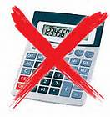
- Jack drew this graph to show how attendance at concerts is related to ticket price.
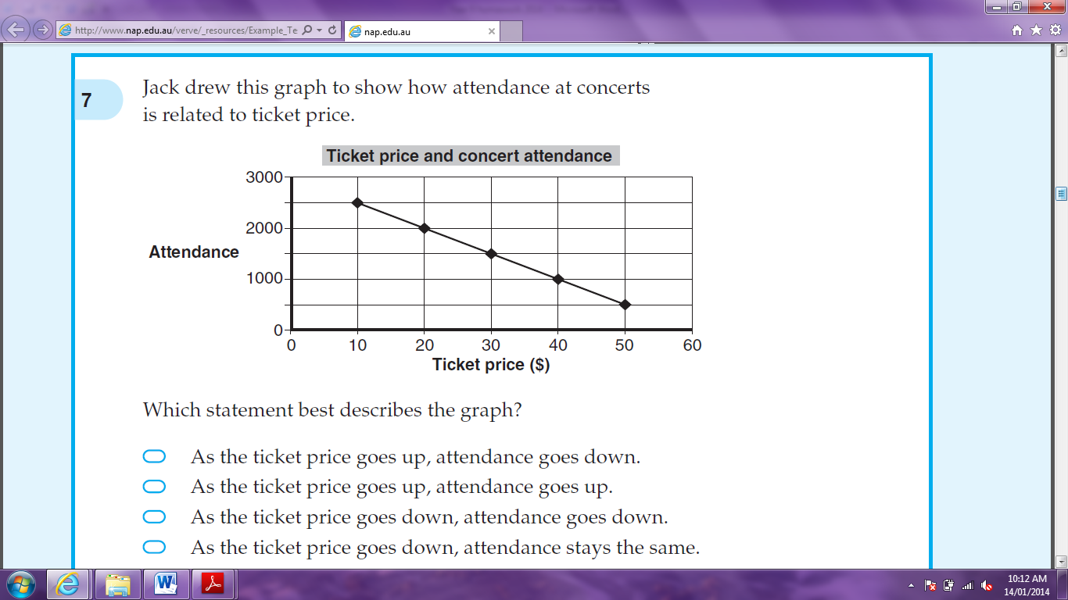

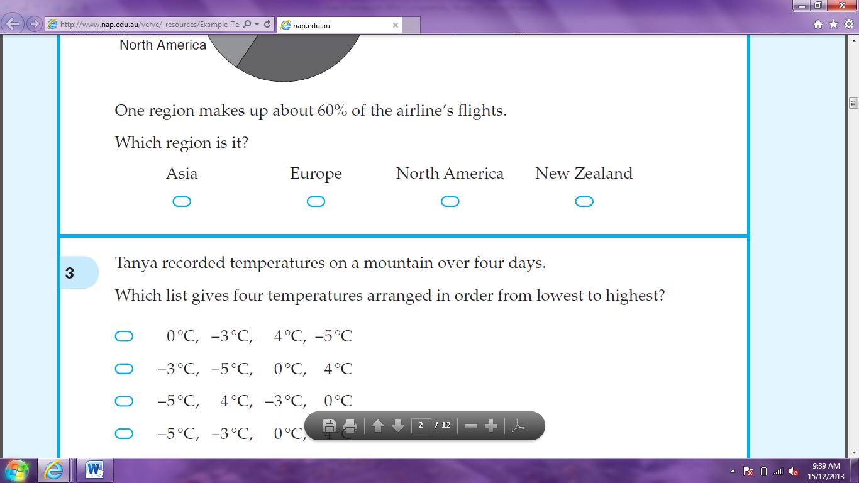
Which statement best describes the graph?

As the ticket price goes up, attendance goes down.

As the ticket price goes up, attendance goes up.

As the ticket price goes down, attendance goes down.
As the ticket price goes down, attendance stays the same.

- Of the 80 children in Year 1 at a school, 50 are girls. What is the ratio of girls to boys?

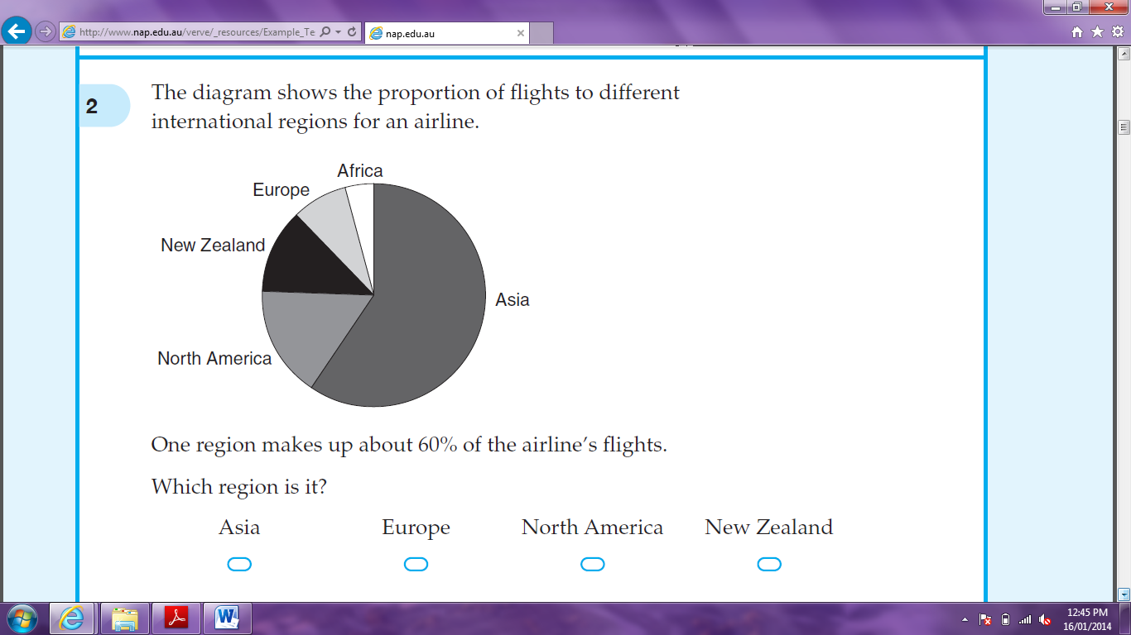
- The diagram shows the proportion of flights to different international regions for an airline. Which region makes up about 60% of the airline’s flights?

- Which of these is the longest distance?




0.1203km 123m 1230cm 12030mm

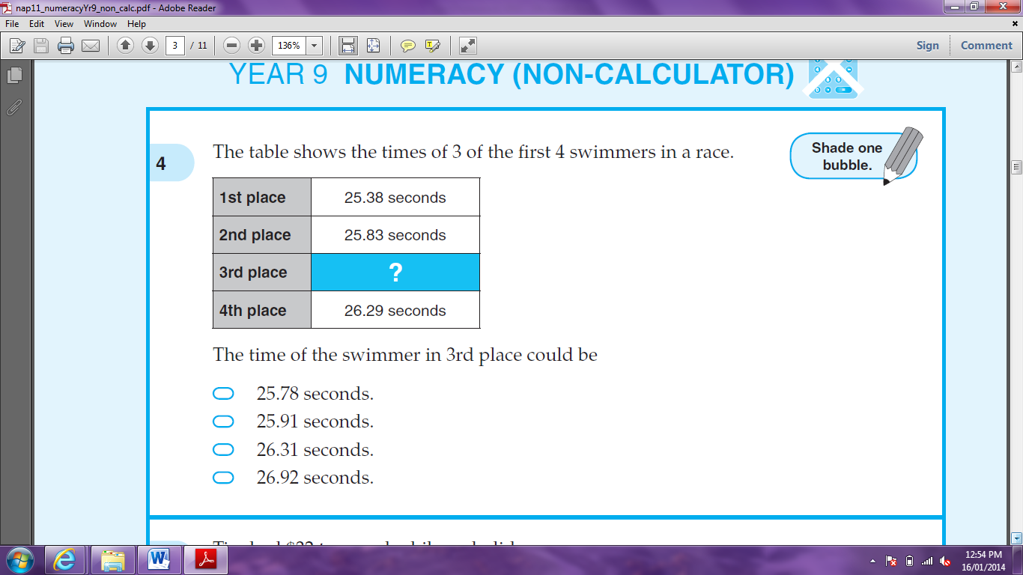

- The table shows the times of 3 of the first swimmers in a race. The time of the swimmer in 3rd place could be?

25.78 seconds.

25.91 seconds

26.31 seconds.
26.92 seconds.

- 1.2 kg and 1500 g is the same as:




1.215 kg 1.35 kg 2.215 kg 2.7 kg

- For which shape are the opposite sides not always equal?




rectangle rhombus square trapezium
- There are 40 pegs in a basket. 15 pegs are yellow and the rest are green. Without looking, Greg takes a peg from the basket. What is the probability that it is green?

- A copier prints 1200 leaflets. One-third of the leaflets are on yellow paper and the rest are on blue paper. There are smudges on 5% of the blue leaflets. How many blue leaflets have smudges?

- In February 2010, the population of the world was approximately 6 800 000 000 people. Another way of writing this number is:




6.8 x 10⁸ 6.8 x 10⁹ 68 x 10⁹ 68 x 10¹⁰

- Joe filled this empty bucket with water from a tap. First the water ran from the tap slowly. Then the water ran quickly until the bucket was nearly full. As the water reached the top of the bucket, he turned the tap off. Which graph best shows how the depth of the water in the bucket changed?
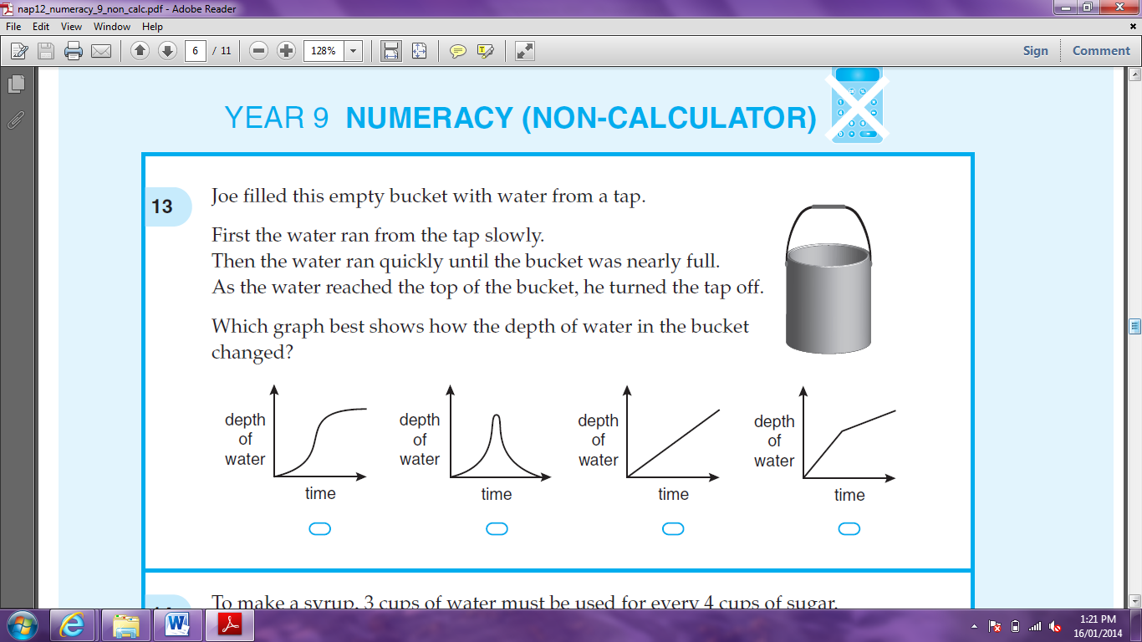

- To make a syrup, 3 cups of water must be used for every 4 cups of sugar. How many cups of water are needed for 6 cups of sugar?

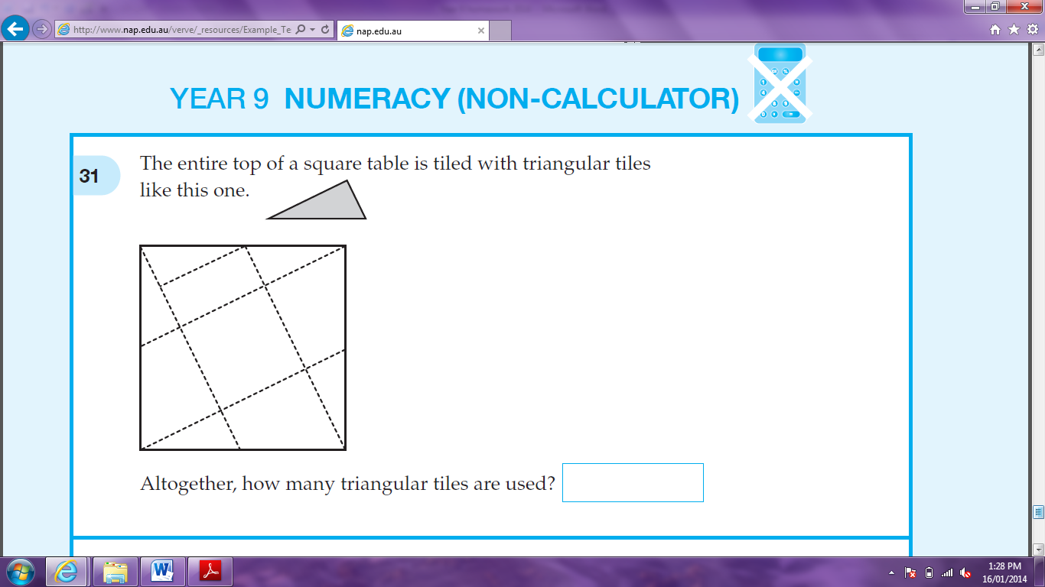

- The entire top of a square table is tiled with triangular tiles like this one. Altogether, how many triangular tiles are used?

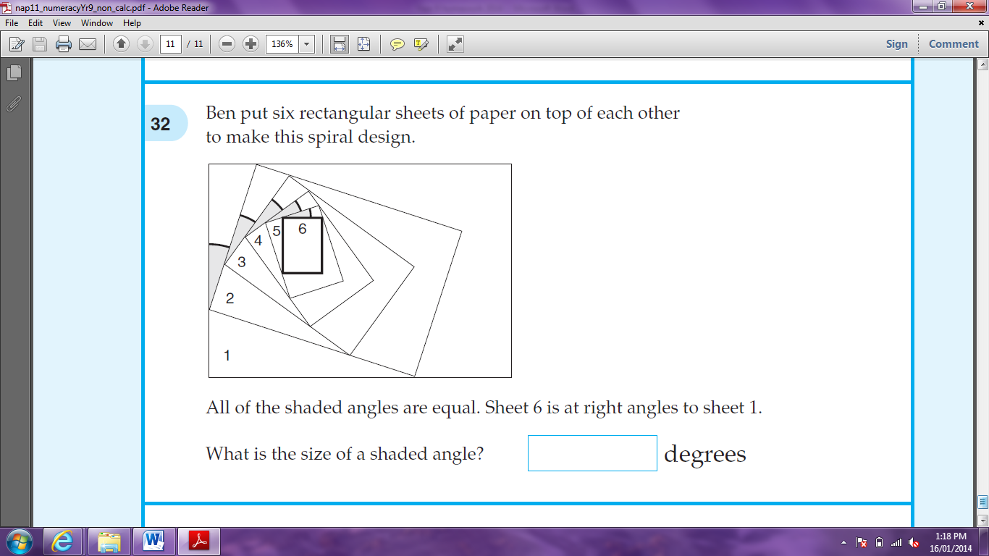
- Ben put six rectangular sheets of paper on top of each other to make this spiral design. All of the shaded angles are equal. Sheet 6 is at right angles to sheet 1. What is the size of a shaded angle?

